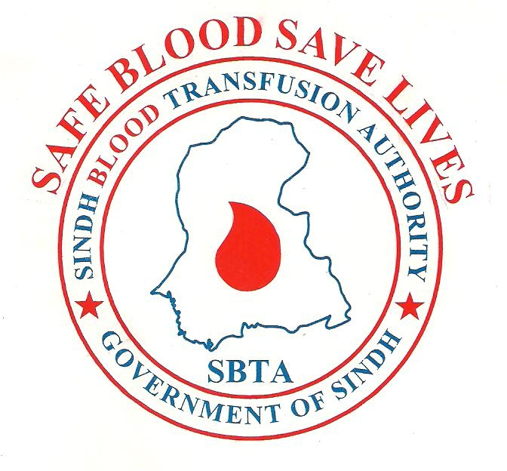

PROVINCIAL SECRETARIAT
SINDH BLOOD TRANSFUSION AUTHORITY
HEALTH DEPARTMENT, GOVERNMENT OF SINDH
Import and Inspection Medical Store Depot: (M.S Depot)
Rafiqui Shaheed Road, Near J.P.M.C Cantt, Karachi
(+92-21) 35650411– 35650412

APPLICATION FOR RENEWAL OF BLOOD BANK LICENSE

DETAILS of Blood Establishment:
Complete Postal Address
Issue Date of Last License
Expiry Date of Last License
License Number
Name of Responsible Person (Doctor or Pathologist)
Contact No. (Responsible Person) | Mobile No. __________________Email: _________________
Contact No. of (Administrator/ Medical Superintendent) | Mobile No. __________________Email: _________________
National Bank Challan No. & Date
Improvements/ Additions made (Jan. 202 – Dec. 202 ) | Equipment: _______________________________________  Staff: ____________________________________________  Procedure/ Process: ____________________________________
Improvement Plan for the next year 202 (if any) | _________________________________________________
Complaints & Suggestions regarding SBTA | ________________________________________________

ADMINISTRATOR: RESPONSIBLE PERSON:
Name: _________________________________ Name: ______________________________

Signature: ______________________________ Signature: ___________________________

Stamp: _________________________________ Stamp: ______________________________

PROVINCIAL SECRETARIAT
SINDH BLOOD TRANSFUSION AUTHORITY
HEALTH DEPARTMENT, GOVERNMENT OF SINDH
Import and Inspection Medical Store Depot: (M.S Depot)
Rafiqui Shaheed Road, Near J.P.M.C Cantt, Karachi
(+92-21) 35650411– 35650412

CIRCULAR

FOR ALL LICENSED BLOOD BANKS

Sindh Blood Transfusion Authority (SBTA) is initiating the renewal process for all issued licenses. SBTA will conduct renewal visits to blood banks throughout the year 2024.

SBTA will not renew any blood license with the following shortcomings, as outlined in the relevant provisions of The Sindh Safe Blood Transfusion Act.

- Insufficient or inappropriate areas.
- Inadequate staff or engagement of non-qualified/ untrained staff.
- Inappropriate equipment.
- Nonobservance of SOPs.
- Use of substandard or expired consumables/ disposables/ solution or water.
- Improper transportation of blood/ blood components or blood samples.
- Improper maintenance of records.

All licensed blood banks are instructed to submit license renewal applications by post, using the attached form, along with required documents and a bank challan of Rs. 1000/- as the yearly renewal fee. The annual report of your blood bank must be attached with the prescribed form.

SECRETARY
SINDH BLOOD TRANSFUSION AUTHORITY
KARACHI

Please attach the following documents with renewal application.

Application will be submitted through Administrator / Medical Superintendent:

- Data Collection Form filled.
- A copy of the last valid license.
- Bank Challan (Original).
- Two Fresh Photo of responsible person 1.5 X 1.5 Inch. (Please attach carefully not sing stapler or paste).
- If any change of responsible person. (Revised registration form & PMDC registration copy).

